FOR IMMEDIATE RELEASE CONTACT: Kim Ina
swc@swcfoundation.org
(415) 566-3487

SPORTS FOR THE WORLD’S CHILDREN TO HOST 15TH ANNUAL
“THEY ARE WORTHY” BENEFIT SOFTBALL TOURNAMENT

SAN FRANCISCO, April 19, 2012 – The Sports for the World’s Children Foundation (SWC) will host its 15th annual “They Are Worthy” benefit softball tournament the weekend of July 14 & 15 at Westlake Park in Daly City. Participants are encouraged to bring new and gently used sports equipment donations to support their youth programs, both local and abroad. All donated equipment and proceeds from the tournament go to providing kids (and communities and schools) with much needed sports equipment, facilities, skills clinics, and mentoring programs. SWC’s current equipment needs include baseballs, bases, basketballs, bats, Frisbees, jump ropes, mitts, soccer balls, sports trading cards, volleyballs, volleyball nets, etc. Entry forms can be found at www.swcfoundation.org.

Tournament format will be round robin and/or double elimination for the coed division(s), and men’s division(s), depending on final number of entries. Two games are always guaranteed. Prizes include T-shirts for championship teams, All Star prizes, and many others.

Last year a total of 11 teams participated in the two divisions of the tournament, and participants donated hundreds of pounds of sports equipment. The equipment was later transported to communities and programs in need, both locally and abroad, through SWC’s “Communities Play” equipment distribution program. Most recently, SWC provided much needed equipment to the following programs:

- A Sports and Intermurals Program of the Skykomish School District. The district serves a predominantly low-income area, with 69% of the students qualifying to receive free or reduced cost lunch, and 19% live below the poverty level. The goals of the program include engaging the students and community in healthier activities, and promoting heath education, social skills, teamwork, and sportsmanship. The equipment provided included bases, basketballs, bats, mitts, water bottles, and softballs.

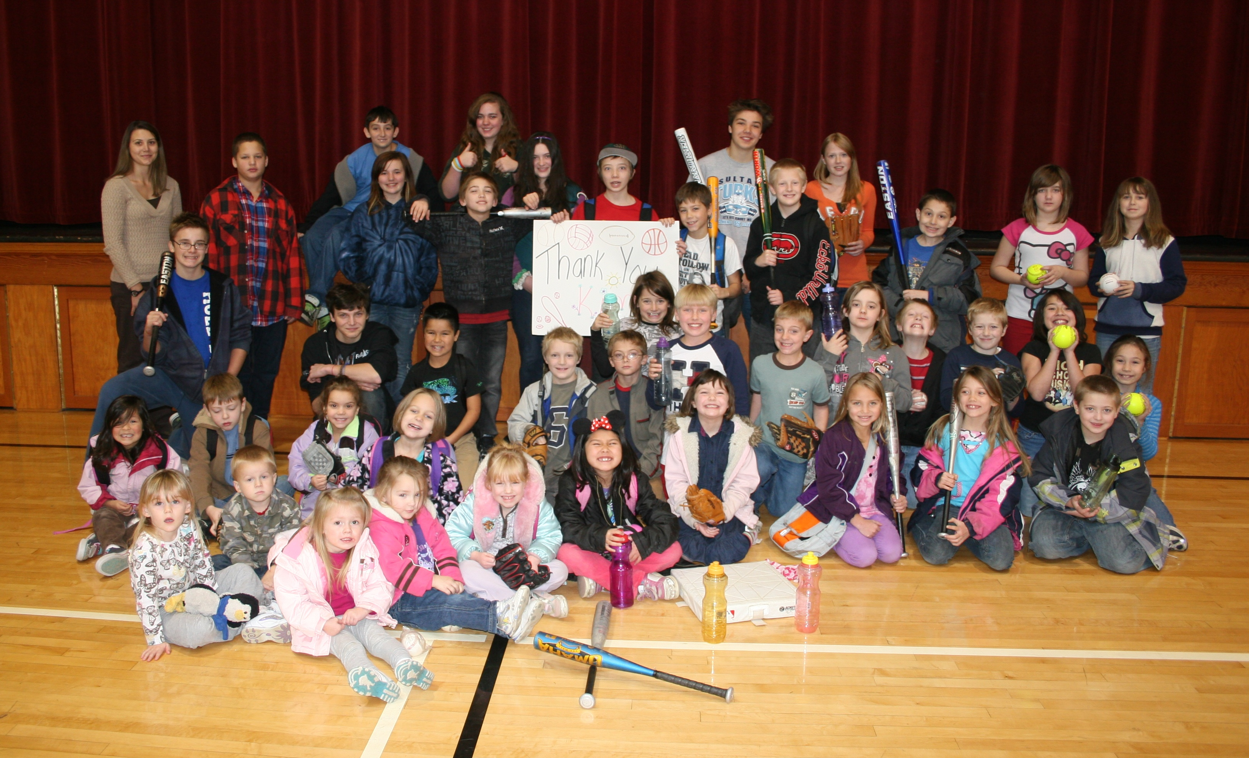

- A girls’ softball program in Todos Santos Baja California Sur, Mexico.

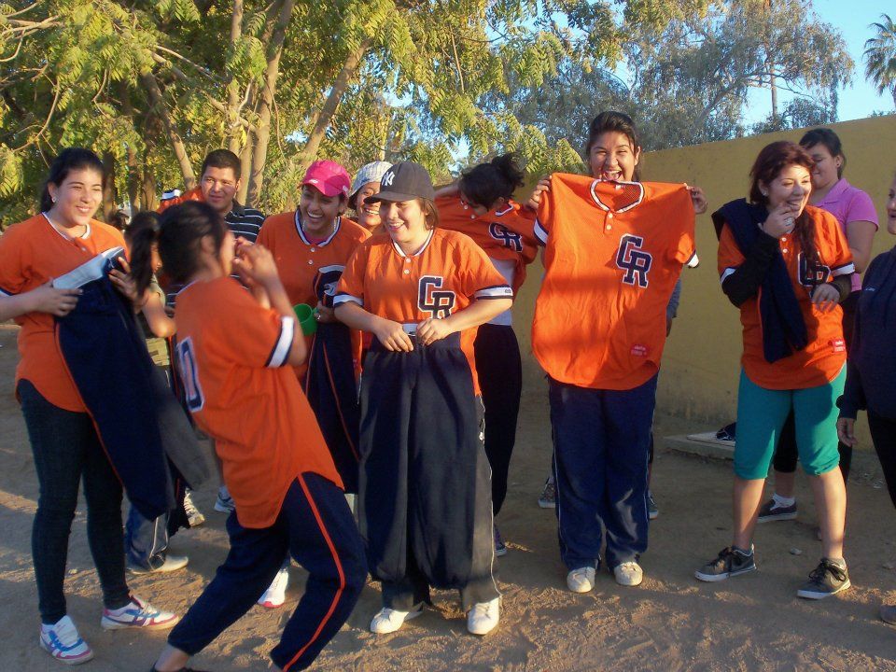

- A little league baseball program in Pescadero, Baja California Sur, Mexico.

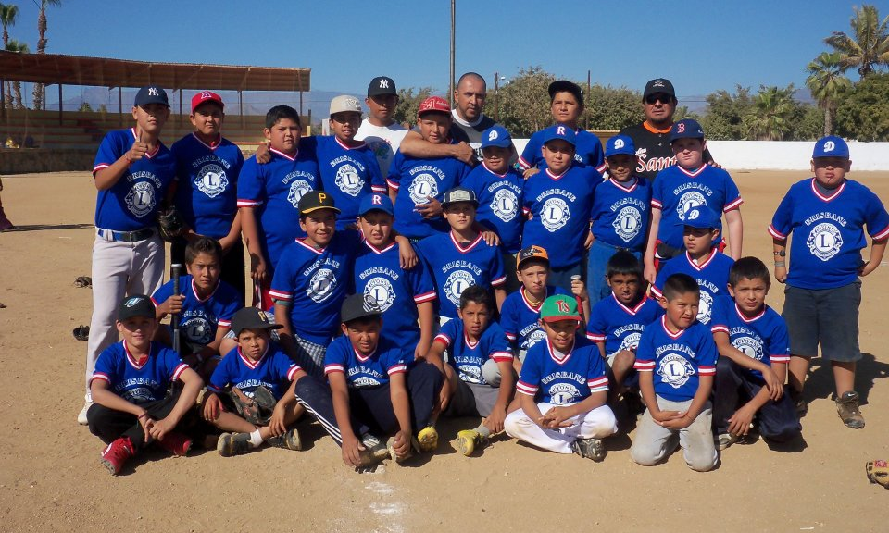

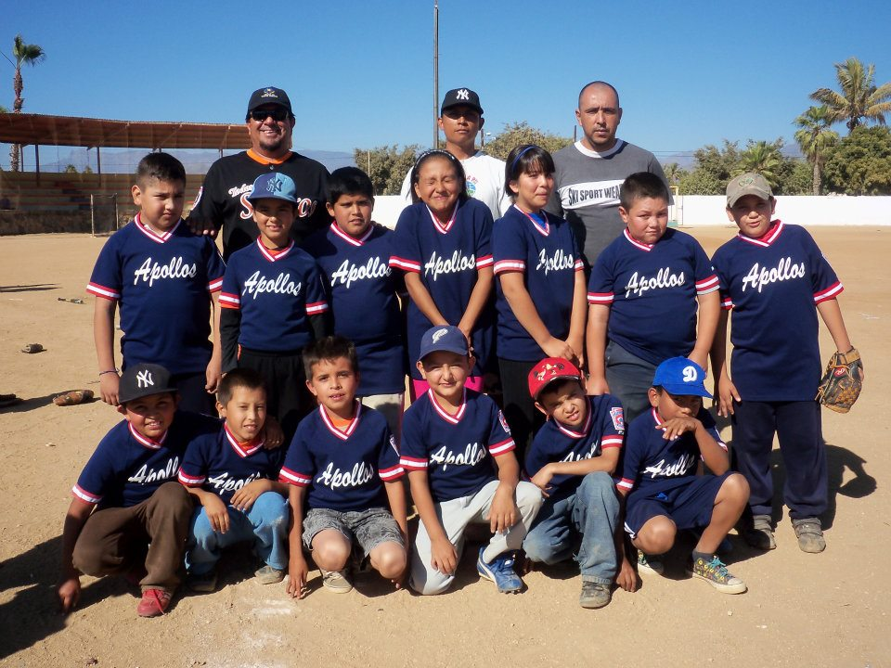

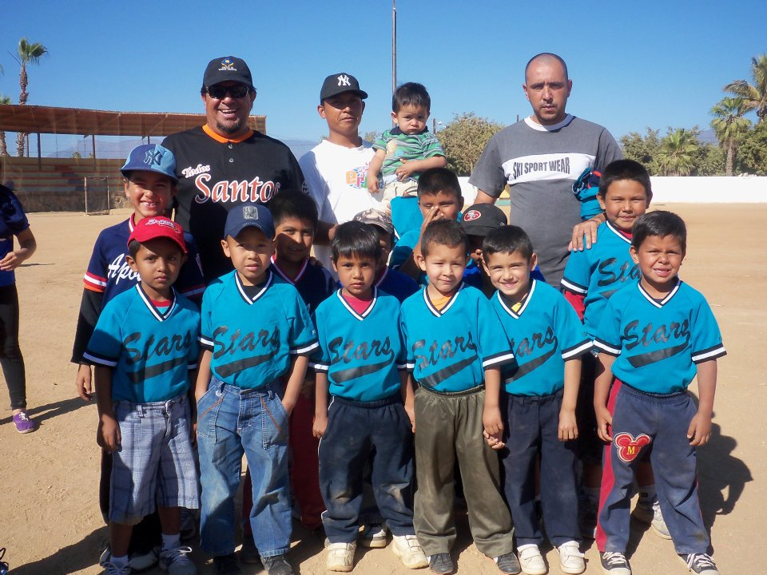

The Sports for the World’s Children Foundation (SWC), based in San Francisco, is a long time supporter of youth participation in sports both locally and abroad. SWC’s mission is to facilitate the creation of ongoing, self-sustaining, quality sports programs for children with limited or no resources. Over the past fourteen years, SWC has benefited more than 16,300 children, ages 5-18, by providing them with thousands of pounds of sports equipment and sports skills instruction and training through its “Communities Play” Program. SWC’s “Communities Play” Program has received past support from Alaska Airlines, Major League Baseball’s Baseball Tomorrow Fund, and the Kristi Yamaguchi Always Dream Foundation.

Interested individuals, teams, and/or sponsors can contact SWC for more information about the benefit softball tournament, their “Communities Play” sports equipment distribution/volunteer program abroad, and/or to receive a DVD about their sports equipment distribution/volunteer programs abroad at swc@swcfoundation.org, (415) 566-3487.

# # #

